**VIVEKANAND EDUCATION SOCIETY’S INSTITUTE OF TECHNOLOGY**

**Department of Computer Engineering**



Project Report on

**Entrepôt Optimisé- A Storage Optimizer**

In partial fulfillment of the Third Year, Bachelor of Engineering (B.E.) Degree in Computer Engineering at the University of Mumbai Academic Year 2020-21

**Submitted by**

Riddhi Khole(D12B-30)

Sakshee Sawant (D12B-51)

Srishti Vazirani (D12B-66)

**Project Mentor**

Dr. Mrs. Gresha Bhatia

(2020-21)

**VIVEKANAND EDUCATION SOCIETY’S INSTITUTE OF TECHNOLOGY**

**Department of Computer Engineering**



**Certificate**

This is to certify that of Third Year Computer Engineering studying under the University of Mumbai have satisfactorily completed the mini project on “***Entrepôt Optimisé- A Storage Optimizer***” as a part of their coursework of Mini Project for Semester-VI under the guidance of their mentor ***Prof. Gresha Bhatia*** in the year 2020-21.

This mini project report entitled “***Entrepôt Optimisé- A Storage Optimizer***” by ***Riddhi Khole, Sakshee Sawant, Srishti Vazirani*** is approved for the degree of ***Bachelor of Engineering in Computer Engineering.***

|  |  |
| --- | --- |
| Programme Outcomes | Grade |
| PO1,PO2,PO3,PO4,PO5,PO6,PO7,  PO8, PO9, PO10, PO11, PO12  PSO1, PSO2 |  |

Date: 15th May, 2021

Project Guide: Internal and External

------------------------------------------

**This page should have the certificate of industrial project (If any)**

**Mini Project Report Approval**

**For**

**T. E (Computer Engineering)**

This mini project report entitled “***Entrepôt Optimisé- A Storage Optimizer***” by ***Riddhi Khole, Sakshee Sawant, Srishti Vazirani*** is approved for the degree of T.E Computer Engg.

Internal Examiner

---------------------------------------------

External Examiner

---------------------------------------------

Head of the Department

-----------------------------------------------

Principal

-----------------------------------------------

Date: 15th May,2021

Place: Mumbai

**Declaration**

We declare that this written submission represents our ideas in our own words and where others' ideas or words have been included, we have adequately cited and referenced the original sources. We also declare that we have adhered to all principles of academic honesty and integrity and have not misrepresented or fabricated or falsified any idea/data/fact/source in our submission. We understand that any violation of the above will be cause for disciplinary action by the Institute and can also evoke penal action from the sources which have thus not been properly cited or from whom proper permission has not been taken when needed.

|  |  |
| --- | --- |
| -----------------------------------------  (Signature)  -----------------------------------------  (Sakshee Sawant D12B-51) | -----------------------------------------  (Signature)  -----------------------------------------  (Srishti Vazirani D12B-66) |
| -----------------------------------------  (Signature)  -----------------------------------------  (Riddhi Khole D12B-30) |  |

Date:15th May, 2021

**ACKNOWLEDGEMENT**

We are thankful to our college Vivekanand Education Society’s Institute of Technology for considering our project and extending help at all stages needed during our work of collecting information regarding the project.

It gives us immense pleasure to express our deep and sincere gratitude to Assistant Professor **Dr. (Mrs.) Gresha Bhatia** (Project Guide) for her kind help and valuable advice during the development of project synopsis and for her guidance and suggestions.

We are deeply indebted to Head of the Computer Department **Dr.(Mrs.) Nupur Giri** and our Principal **Dr. (Mrs.) J.M. Nair** for giving us this valuable opportunity to do this project.

We express our hearty thanks to them for their assistance without which it would have been difficult in finishing this project synopsis and project review successfully.

We convey our deep sense of gratitude to all teaching and non-teaching staff for their constant encouragement, support and selfless help throughout the project work. It is a great pleasure to acknowledge the help and suggestion, which we received from the Department of Computer Engineering.

We wish to express our profound thanks to all those who helped us in gathering information about the project. Our families too have provided moral support and encouragement several times.

**Department of Computer Engineering**

**Course Outcome for T.E Mini Project**

Learners will be to,

|  |  |
| --- | --- |
| **Course Outcome** | **Description of the Course Outcome** |
| CO 1 | Able to apply the relevant engineering concepts, knowledge and skills towards the project. |
| CO2 | Able to identify, formulate and interpret the various relevant research papers and to determine the problem. |
| CO 3 | Able to apply the engineering concepts towards designing solutions for the problem. |
| CO 4 | Able to interpret the data and datasets to be utilized. |
| CO 5 | Able to create, select and apply appropriate technologies, techniques, resources and tools for the project. |
| CO 6 | Able to apply ethical, professional policies and principles towards societal, environmental, safety and cultural benefit. |
| CO 7 | Able to function effectively as an individual, and as a member of a team, allocating roles with clear lines of responsibility and accountability. |
| CO 8 | Able to write effective reports, design documents and make effective presentations. |
| CO 9 | Able to apply engineering and management principles to the project as a team member. |
| CO 10 | Able to apply the project domain knowledge to sharpen one’s competency. |
| CO 11 | Able to develop professional, presentational, balanced and structured approach towards project development. |
| CO 12 | Able to adopt skills, languages, environment and platforms for creating innovative solutions for the project. |

**ABSTRACT**

For the smooth working of a warehouse, it is crucial to have an efficient storage optimization system. Warehouse Management System (WMS) is designed to introduce improvement into every aspect of a company’s warehouse operations and offers an organized approach to manage efficiency. WMS is found to have a positive impact on companies' performance on operations management measures.WMS implementation is crucial in bringing cost reduction in operational level, effective management in management level, as well as improvement of the company's competitiveness in strategic level. Companies that manage warehousing of their products are expected to implement WMS in order to maintain their competitive edge in the global marketplace.It provides comprehensive fulfilment centre and warehouse management, including receiving, stocking, picking and related warehouse tasks. The best-of-breed solution leverages state-of-the-art technology to deliver all of the functionality needed to maximise operational efficiency and increase throughput, thus meeting the primary focus of the warehouse in accuracy and timely fulfilment of customer orders.

Here, we have a storage management system that is beyond storing and shipping items. Our application, Entrepôt Optimisé mainly aims to optimize the storage of a warehouse and in the process also maximize the profit. Given the name of the commodity and respective volume associated, our model predicts profit and allocates the storage. We introduce an efficient storage management system using a class-based storage strategy which ensures that the high demand products are always given comparatively more precedence, thus ensuring a good profit margin to the warehouse without compromising on its storage efficiency.

**Index**

**Title Page no**

**Chapter 1: Introduction 12**

1.1 Introduction to the project 12

1.2 Motivation 13

1.3 Lacuna in the existing systems 13

1.4 Problem Definition 13

1.5 Relevance of the Project 14

1.6 Methodology used 14

**Chapter 2: Literature Survey** (with citation of references) **15**

A. Brief Overview of Literature Survey 15

B. Related Works

2.1 Research Papers Referred ( Mentioned in IEEE format ) 15

a. Abstract of the research paper ( in your own word) 15

b. Inference drawn 15

2.2 Patent search 16

**Chapter 3: Requirement Gathering for the Proposed System 17**

3.1 Introduction to Requirement Gathering 17

3.2 Functional Requirements 17

3.3 Non-Functional Requirements 17

3.4 Hardware & Software Requirements 18

**Chapter 4: Proposed Design 19**

4.1 System Design / Conceptual Design (Architectural) 19

4.2 Modular Diagram 19

4.2 Detailed Design 20

4.3 Project Scheduling & Tracking using Timeline / Gantt Chart 21

**Chapter 5: Implementation of the Proposed System 22**

5.1. Methodology applied 22

5.2. Algorithms implemented 23

5.3 Datasets source and utilization 25

5.4. Screenshots (GUI) of the project 26

**Chapter 6: Testing of the Proposed System**

6.1. Test cases and results 32

**Chapter 7: Result Analysis 34**

7.1.Perforamnce Evaluation measures 34

7.2 Input Parameters / Features considered 34

7.3 Comparison of results with existing systems 35

7.4 Inference drawn 35

**Chapter 8: Conclusion 37**

8.1 Limitations 37

8.2 Conclusion 37

8.3 Future Scope 37

**References (papers + books + Patent) 38**

**Appendix (Paper I & II Details) 39**

**1. Paper I & II Details 39**

1. Plagiarism report
2. Project review sheet

**2. Video Presentation Link 40**

**TABLE OF CONTENTS**

**CHAPTER INDEX:**

|  |  |
| --- | --- |
| **CHAPTER NO.** | **PAGE NO.** |
| CHAPTER 1 | 12 |
| CHAPTER 2 | 15 |
| CHAPTER 3 | 17 |
| CHAPTER 4 | 19 |
| CHAPTER 5 | 22 |
| CHAPTER 6 | 31 |
| CHAPTER 7 | 33 |
| CHAPTER 8 | 35 |

**FIGURES/GRAPH INDEX:**

|  |  |
| --- | --- |
| **FIGURE NAME & NO.** | **PAGE NO.** |
| Fig 4.3.1 | 19 |
| Fig 4.3.2 | 19 |
| Fig 4.3.3 | 20 |
| Fig 4.3.4 | 20 |
| Fig 4.4.1 | 21 |
| Fig 7.2.1 | 34 |
| Fig 7.2.2(a) | 35 |
| Fig 7.2.2(b) | 35 |

**LIST OF TABLES:**

|  |  |
| --- | --- |
| **TABLE NAME & NO.** | **PAGE NO.** |
| Table 5.1.1 | 23 |
| Table 6.1 | 32 |
| Table 7.3 | 35 |

**CHAPTER 1: INTRODUCTION**

**1.1 INTRODUCTION TO THE PROJECT**

A warehouse management system (WMS) is a software application that can be used to control and manage the daily processes in a warehouse. The WMS software controls incoming goods and storage, optimizes the picking and dispatch of orders and advises on replenishing stocks. Traditionally, the warehouses were labor intensive, required a lot of work and increased the risk of errors. In such cases, the company has often faced many problems such as slowdowns or lost orders, wasted time searching for products and outages of inventory space, boxes stacking in aisles blocking the path and wasting valuable space, and much more. However, multiple technological advances have produced results. As a result, warehouse operations are controlled by the system. Taking a proactive rather than reactive approach highlighted better planning and operations management. It is always best to think about storage practices regardless of the size of the warehouse. It's big or small. Efficient warehouse management systems should always help us to maximize our available storage area and minimize the time and effort required to search for items. Such things reward improved efficiency and customer experience, accelerate operations, and reduce costs. of operation and storage management.

The warehousing is mainly associated with two main factors:

1) Minimizing the total operations cost

2) Granting the desired level of service

In order to meet the above aims, the warehouse management demands to consider the three main elements of:

1) Labor

2) Space

3) Equipment

The apt combination of these elements functioning individually, as well as together, will result in an optimum solution

Our system Entrepôt Optimisé is a semi-automated warehouse management system that mainly focuses on improving storage location and allocation strategy through the use of data technology including data collection, cluster analysis, and profit prediction to improve order picking efficiency through optimum storage allocation. The application mainly aims to optimize the storage of a warehouse and in the process also maximize the profit.

**1.2 MOTIVATION**

The motivation for doing this project was primarily an interest in undertaking a challenging project in an interesting area of research. The opportunity to learn about a new area of computing not covered in lectures was appealing. Furthermore, some common issues encountered in a traditional WMS such as lack of communication in regards to inventory, difficulty customizing management practices, predicting lead time, common warehouse problems such as redundant processes, poor facility layout, seasonality in demand, high labor costs and inaccurate inventory information require robust systems to motivated us to a great extent.

**1.3 LACUNA IN EXISTING SYSTEM**

In previous systems, the company faced a number of problems derived from the low accuracy of storage records, such as:

* Delays and loss of orders
* Rework and waste of time to find products
* Running out of space with boxes spilling into the aisles
* Boxes piling up, blocking the way and wasting valuable floor space
* Storing products of varying height reduces warehouse storage capacity

The result of this set of problems reflected on the dissatisfaction of the customers, which no longer relied on the delivery performance and quality of operations executed by the company.

**1.4 PROBLEM DEFINITION**

Our main focus is to improve storage location strategy through the use of data technology, including data collection, cluster analysis ,profit prediction to improve order picking efficiency through optimum storage allocation.Optimizing a warehouse creates conditions in which high-demand items in-demand are always stocked, leading to timely order fulfilment. The application mainly aims to optimize the storage of a warehouse and in the process also maximize the profit. Thus, the Warehouse Management System is directed toward owners of small to large stores and stock managers who are responsible for maintaining sufficient goods on hand in a retail or manufacturing business. The storage efficiency is shown to be enhanced by the improved strategy.

**1.5 RELEVANCE OF THE PROJECT**

As humans, we are capable of many great things, but when it comes to finding the right stock, optimum routes, and general inventory control, the software can do it much more efficiently. Our WMS will benefit their operational efficiency for both labor and physical space by monitoring work processes at various levels, enhancing productivity, and increasing asset utilization. WMS automation assists with inventory control in a way that improves accuracy, throughput, and speed.With space at a premium, an increasing number of warehouses are seeking to optimize the space they already have. Turning towards automated warehouse software can help to [reduce the required floor area](http://www.3plnews.com/3pl/how-warehouse-automation-saves-space-and-improves-your-supply-chain.html) considerably.

**1.6 METHODOLOGY USED**

**The methodology used for our system is broadly divided into 2 categories:**

1. **Receiving and Inspection:**

* Manages receiving/staging area
* Classify products into categories according to relative profit obtained
* Allocate most accessible aisles category-wise to reduce allocation and picking distance
* Predict profit generated by the product and pass values to main storage allocation model
* Designates automatically storage locations
* Supports systematic classification of items
* Controls quantities

1. **Storage Process:**

* Controls FIFO
* Updates records in real time
* Recognizes the physical storage limitation of each address
* Checks storage at the correct addresses
* Defines usage characteristics for each storage location
* Stores accurately
* Confirms transfer and replenishment

**CHAPTER 2: LITERATURE SURVEY**

1. **BRIEF OVERVIEW OF LITERATURE SURVEY**

A literature review is a survey of scholarly sources (such as books, journal articles, and theses) related to a specific topic or research question. It is often written as part of a thesis, dissertation, or research paper, in order to situate your work in relation to existing knowledge.A literature survey or a literature review in a project report is that section which shows the various analyses and research made in the field of your interest and the results already published, taking into account the various parameters of the project and the extent of the project.

1. **RELATED WORKS**

**2.1 RESEARCH PAPERS REFERRED**

**2.1.1 The design of web-based warehouse management system**

Zizhuo Yang, Jun Wang, Qianmin Su and Bocheng Zhong, "The design of web-based warehouse management system," Proceeding of the 11th World Congress on Intelligent Control and Automation, 2014, pp. 5077-5081, doi: 10.1109/WCICA.2014.7053577.

The paper illustrates how a web based Warehouse Management System is perfectly capable of solving the problems of a traditional enterprise warehouse management system mainly underutilization of the company’s resources

**2.1.2 Warehouse Management System and Business Performance: Case Study of a Regional Distribution Centre**

Au Yong, Hui Nee. (2009). Warehouse Management System and Business Performance: Case Study of a Regional Distribution Centre.

This paper examines the various practices followed by the WarehouseManagement System and analyses the impact of those practices on the economic growth of the warehouse.It concludes how important it is to have an efficient Warehouse Management System.

**2.1.3 Warehouse Management System Development Base on Open Source Web Framework**

C. Zhou and Q. Fei, "Warehouse Management System Development Base on Open Source Web Framework," *2016 International Conference on Industrial Informatics - Computing Technology, Intelligent Technology, Industrial Information Integration (ICIICII)*, 2016, pp. 65-68, doi: 10.1109/ICIICII.2016.0027.

The paper helps solve the problem of expensive and complex Warehouse Management Systems by guiding us to design WMS capable of performing basic functions for small businesses using bootstrap and django.

**2.1.4 Research on k-means Clustering Algorithm: An Improved k-means Clustering Algorithm**

S. Na, L. Xumin and G. Yong, "Research on k-means Clustering Algorithm: An Improved k-means Clustering Algorithm," *2010 Third International Symposium on Intelligent Information Technology and Security Informatics*, 2010, pp. 63-67, doi: 10.1109/IITSI.2010.74.

The paper studies K-means clustering algorithm and provides an improvised K-means algorithm with reduced time complexity. The paper shows that clustering is popularly used for large datasets which is perfectly applicable in handling the data of any warehouse.

**2.1.5 Multiple Knapsack Problems. In: Knapsack Problems**

Kellerer H., Pferschy U., Pisinger D. (2004) Multiple Knapsack Problems. In: Knapsack Problems. Springer, Berlin, Heidelberg.

This paper explains how the standard 0/1 knapsack problem can be generalised into a multiple knapsack problem with different capacities. It also studies the concept of upper bounds for a multiple knapsack problem. The paper explains the concept of multiple knapsacks considering various factors and provides generalised equations for the algorithm.

**2.2 Patent Search**

**2.2.1** [**GB2396858A**](https://worldwide.espacenet.com/patent/search?q=pn%3DGB2396858A) **Order handling system with product expiry date identification**

An order-handling-inventory management system for products including: a database capable of containing information about the products, including availability and location of the products, and physical aspects of the products including one or more of length, width, thickness, volume or weight; a radio frequency subsystem, the products forming at least part of an inventory and a order-receiving-processing subsystem for receiving orders for products is mentioned.

**2.2.2** [**US2012215576A1**](https://worldwide.espacenet.com/patent/search?q=pn%3DUS2012215576A1) **ALLOCATING TASKS TO RESOURCES**

Tasks of varying sizes may be allocated to multiple knapsacks (resources) both with multiple dimensions (domain principles) of a given size according to one or more desired criteria. For instance, sales territory management involves determining the allocation of items (accounts) of varying sizes to multiple knapsacks (territories or sales representatives) both with multiple dimensions (business principles) of a given size according to one or more desired criteria.

**CHAPTER 3: REQUIREMENT GATHERING FOR THE PROPOSED SYSTEM**

**3.1 INTRODUCTION TO REQUIREMENT GATHERING**

Requirements gathering is an exploratory process that involves researching and documenting the project's exact requirements from start to finish. Effective requirements gathering and requirements management start at the beginning of the project.

Requirement’s elicitation (also known as Requirements Gathering or Capture) is the process of generating a list of requirements (functional, system, technical, etc.) from the various stakeholders (customers, users, vendors, IT staff, etc.) that will be used as the basis for the formal Requirements Definition.

**3.2 FUNCTIONAL REQUIREMENTS**

* An admin account that will serve the purpose of handling the whole system.
* Monitoring storage and location of packages.
* Giving clients freedom to choose from a range of products.
* Based on the demand, analyse the profits.
* A feedback model that helps for recommendation.
* Record information about shipped and received goods at exit and entry points respectively.
* Category wise aisle allocation.
* Allocation of racks for respective categories according to the floor plan.

**3.3 NON-FUNCTIONAL REQUIREMENTS**

* System should be able to handle a large number of users using the service simultaneously.
* Datasets of previous years sales, current goods and employees are to be used.
* Predictions of the system should be accurate to a certain extent.
* The administrator has the final call to take the decision.
* Efficient performance of the system.
* Proper accountability which includes not allowing one user to access other user’s accounts.
* The administrator only can manage all the accounts.
* Proper user authentication should be provided.

**3.4 HARDWARE AND SOFTWARE REQUIREMENTS**

1. **HARDWARE**

* Microsoft Windows 7/8/10 (32-bit or 64 bit)
* 4 GB RAM Minimum
* 2 GB of available disk space minimum
* 1280 X 800 Screen resolution

1. **SOFTWARE**

* Django
* ML algorithms
* Google Colaboratory
* Atom
* Python (3.7) 64-bit
* MS Excel
* Sqlite3

**CHAPTER 4: PROPOSED DESIGN**

**4.1 SYSTEM / CONCEPTUAL DESIGN (ARCHITECTURE)**

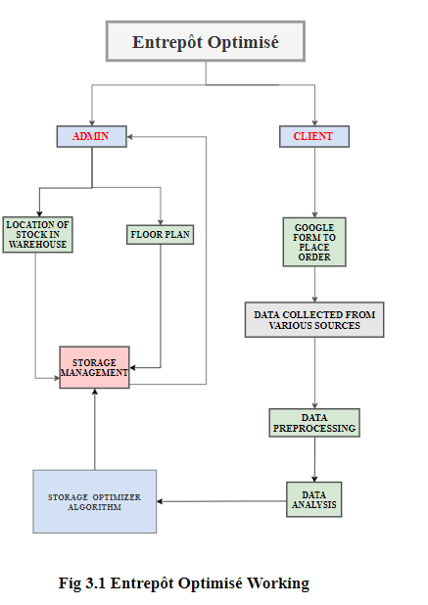

Fig 4.1

**4.2 MODULAR DIAGRAM**

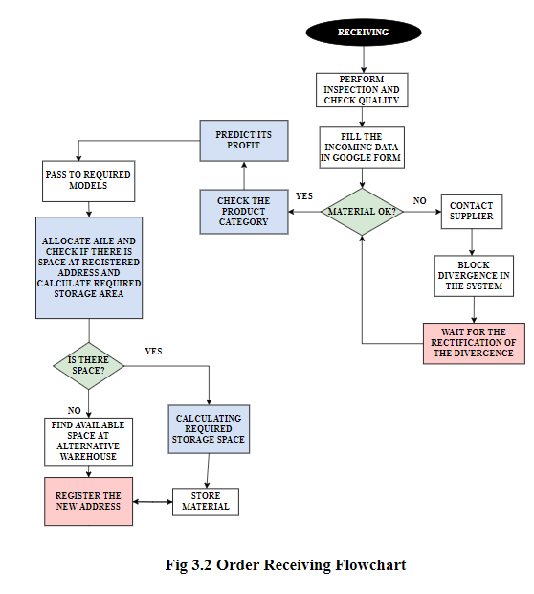

Fig 4.2

**4.3 DETAILED DESIGN**

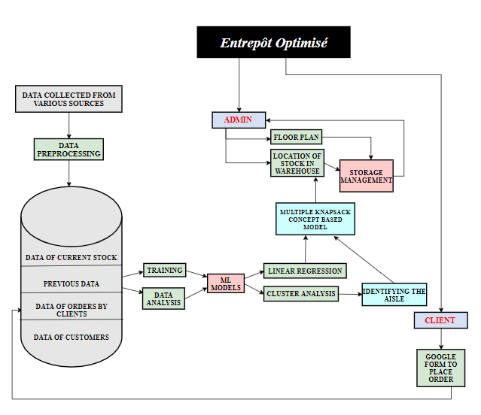

Fig 4.3

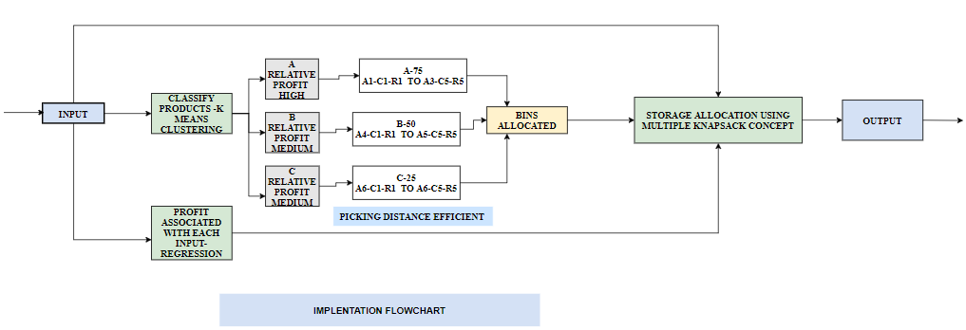

Fig 4.4

**4.4 PROJECT SCHEDULING AND TRACKING USING TIMELINE/ GANTT CHART**

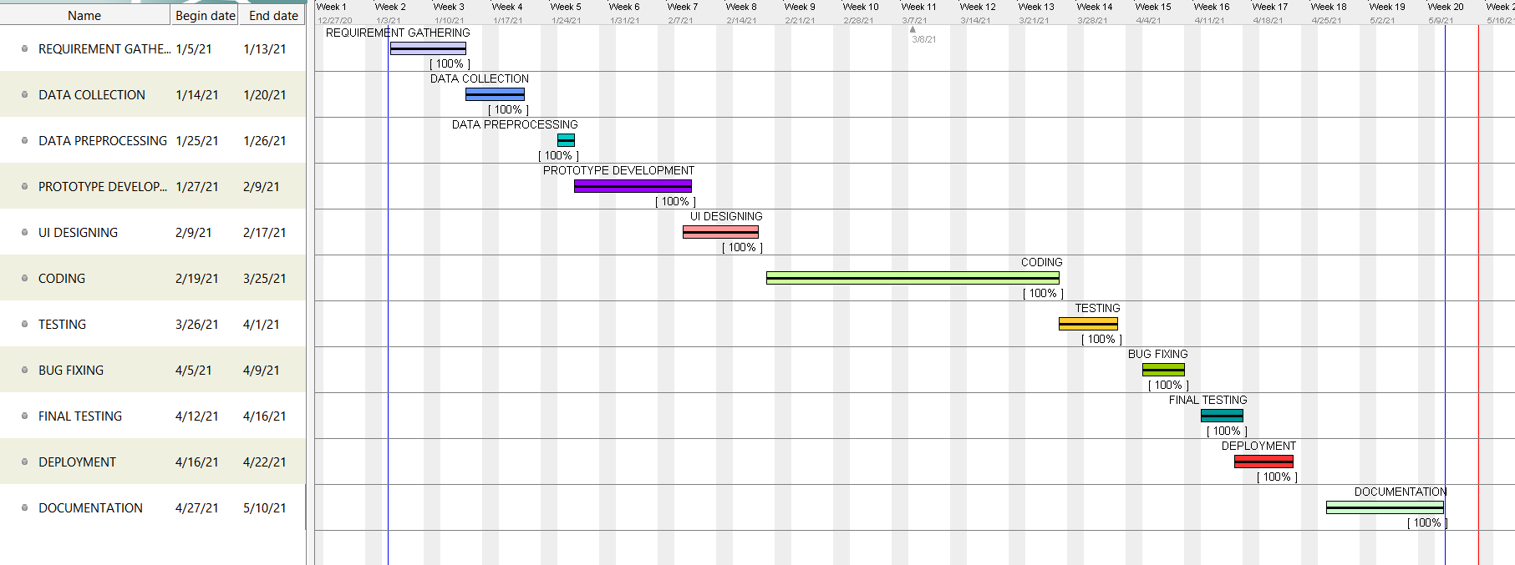

**Fig 4.4.1**

**CHAPTER 5: IMPLEMENTATION OF PROPOSED SYSTEM**

**5.1 METHODOLOGY APPLIED**

To perform optimized storage allocation of commodities we have developed a web application: Entrepôt Optimisé. The project was implemented using the Django framework, Django being a scalable and reliable framework[7]. This web application acts as an interface to take input - the space occupied by each commodity and thereby display the bins to be allocated as output. The methodology adopted for effective storage management is explained below.

**5.1.1 Profit Prediction Model**

Profit Prediction Model-Profitmargin prediction is effective to help inventories know their customers better and plan the picking and storage allocation depending on how much profit a particular commodity can give. Regression model would be applied on the dataset consisting of the space occupied and profit generated by the product over the last few years.

**5.1.2 Category Classification Model**

K-means algorithm is used to confirm our suppositions with respect to grouping of data. In our system Entrepôt Optimisé, we use this algorithm to classify our data into three categories namely A, B and C based on the quantity and the demand of the respective product. The products in the respective category are stored based on their demand .The products in Category A are the ones which have higher demand with respect to the other two categories and are stored in the aisles which are the most accessible during entry and pickup. Similar to Category A, we have Category B which has products with moderate demand and Category C consisting of products with demand lesser than the above two categories. This algorithm aims to improve our storage picking and storing time hence contributing in optimization of our system. Since Category A has the highest demand, it’s products have more racks allocated to it than Category B and C. Similarly Category B has more racks allocated than Category C.The naming convention followed below is : A stands for ‘Aisle’, C for ‘Column’ and R for ‘Racks’.

|  |  |  |
| --- | --- | --- |
| A[75] | B[50] | C[25] |
| A1-C1-R1→A3-C5-R5 | A4-C1-R1**→**A5-C5-R5 | A6-C1-R1**→**A6-C5-R5 |

**Table 5.1.1**

**5.1.3 Storage Optimization Algorithm**

After calculating the profit associated with the product and classifying the category of the product we get the list of racks where the product has to be stored. The best fitting racks for the given input is computed using combinatorial optimization technique- Multiple Knapsack.

The objective is to select a feasible subset of C where maximum items of N can be stored without exceeding the capacities and the total profit of N is maximized. The final allocated racks are then displayed on the web app. The packages then can be transported to their assigned location.

Our system Entrepôt Optimisé is a customizable project where the warehouse administrator can change the rack size, number of aisles, columns and racks. Based on past data the profits can be predicted and the products can be stored based on their demand and space occupied. According to the data provided by the warehouse admin, our system will allocate optimum solutions for storage.

**5.2 ALGORITHMS IMPLEMENTED**

**5.2.1 Regression Model - Linear Regression**

Linear regression is perhaps one of the most well known and well understood algorithms in statistics and machine learning. Linear regression is a linear approach to modelling the relationship between a scalar response and one or more explanatory variables.Regression being an effective tool in machine learning predictive analysis is used in our project to find the association between the volume of the products and profit hence earned.

**5.2.2Clustering Model - K-means clustering**

Category Classification-K means clustering is an algorithm which works on grouping data into K-clusters based on similar features. *K*-means clustering is a type of [unsupervised learning](https://blogs.oracle.com/ai-and-datascience/post/supervised-vs-unsupervised-machine-learning), which is used when you have unlabeled data (i.e., data without defined categories or groups). The goal of this algorithm is to find groups in the data, with the number of groups represented by the variable *K*. The algorithm works iteratively to assign each data point to one of *K* groups based on the features that are provided. Data points are clustered based on feature similarity.

**5.2.3 Combinatorial Optimization - Multiple Knapsack**

The multiple knapsack problem is a generalization of the standard knapsack problem (KP) from a single knapsack to m knapsacks with (possibly) different capacities. The objective is to assign each item to at most one of the knapsacks such that none of the capacity constraints are violated and the total profit of the items put into knapsacks is maximized. Here, the number of inputs N = {1,.....n} is given with the volume occupied by each product $V_{j}$, j= 1, ... ,n and their profits $P_{j}$. The set of knapsacks i.e. the list of racks is denoted by M = {1,.....,m} with volume capacities $C_{i}$ i=1,...,m.

Maximise: $\sum_{i=1}^{m}{}$ $\sum_{j=1}^{n}{}$ $p_{j}$ $x_{ij}$

Subject to: $\sum_{j=1}^{n}{}$ $v_{j}$ $x_{ij}$ $≤$ $c_{i}$, i = 1, … , m ,

$\sum_{i=1}^{m}{}$ $x_{ij}$ $≤$ $1$, j = 1, … ,n,

$x_{ij}$ $ϵ$ {0, 1} , i = 1, … , m , j = 1, … ,n

**5.3 DATA SOURCE AND UTILIZATION**

Datasets:

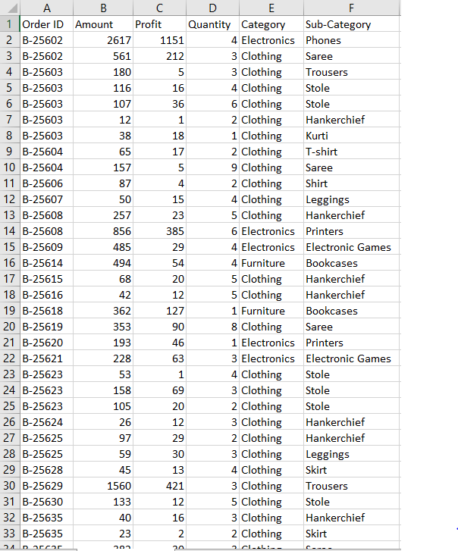 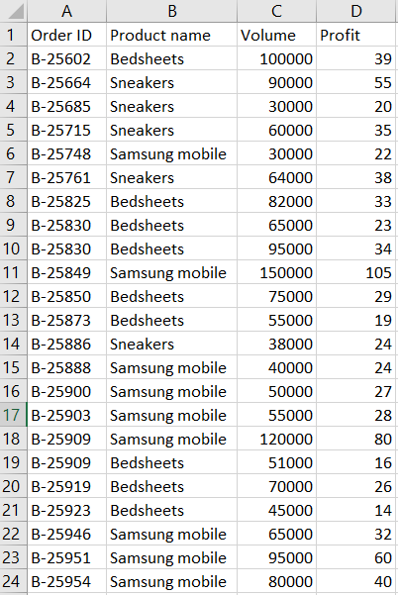

Rack Allocation Dataset:

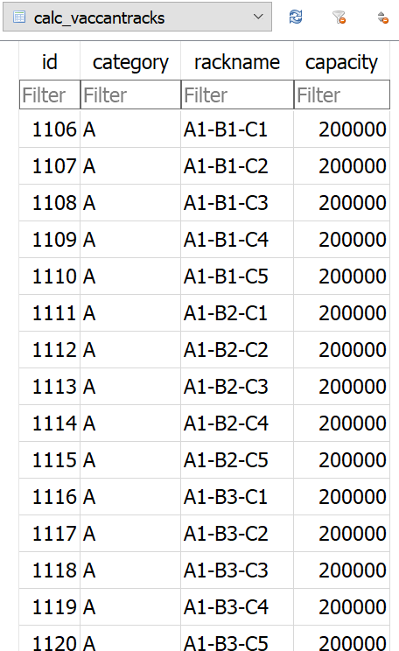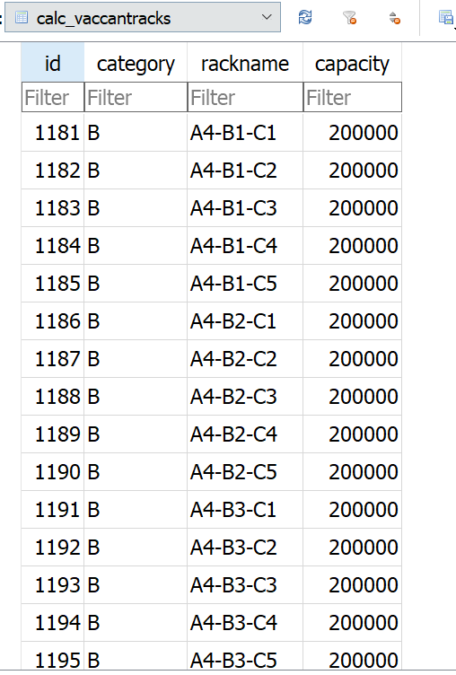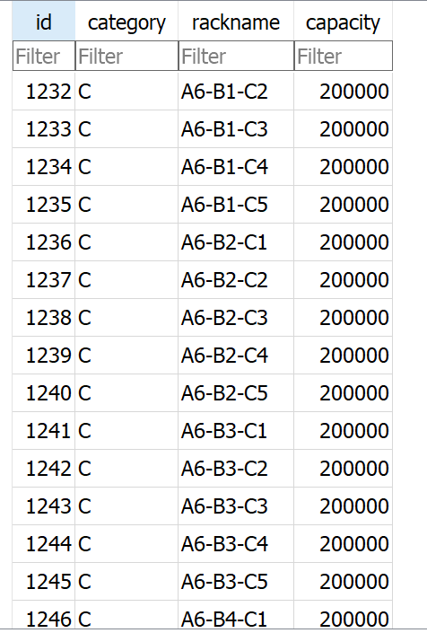

Product Info Dataset:

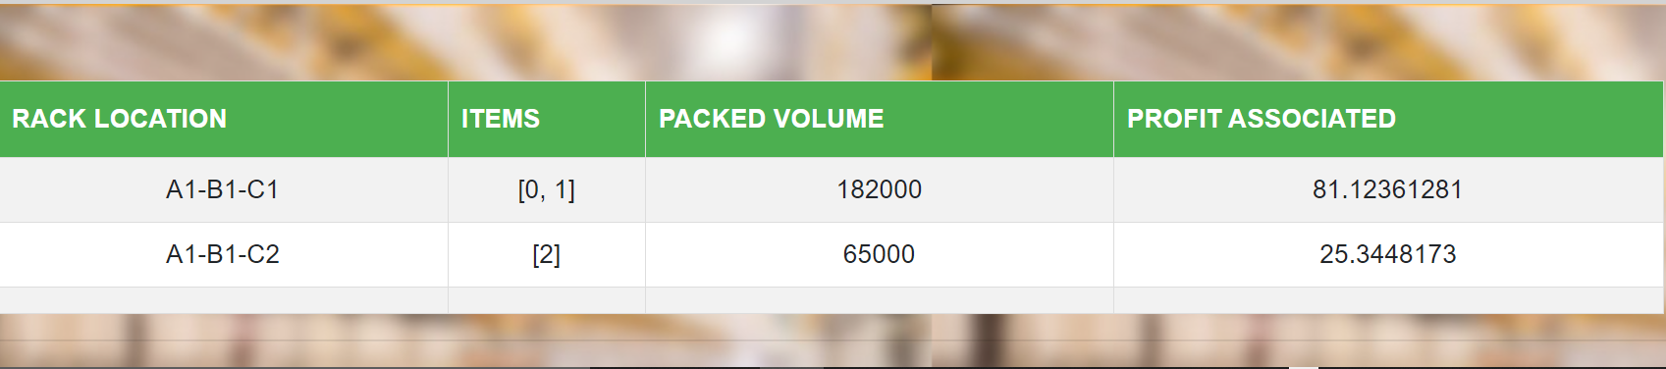

In the proposed system we have used a dataset in csv format from [Kaggle](https://www.kaggle.com/manishkc06/engineering-graduate-salary-prediction) .

**5.4 SCREENSHOTS (GUI) OF OUR PROJECT**



**Home page:**

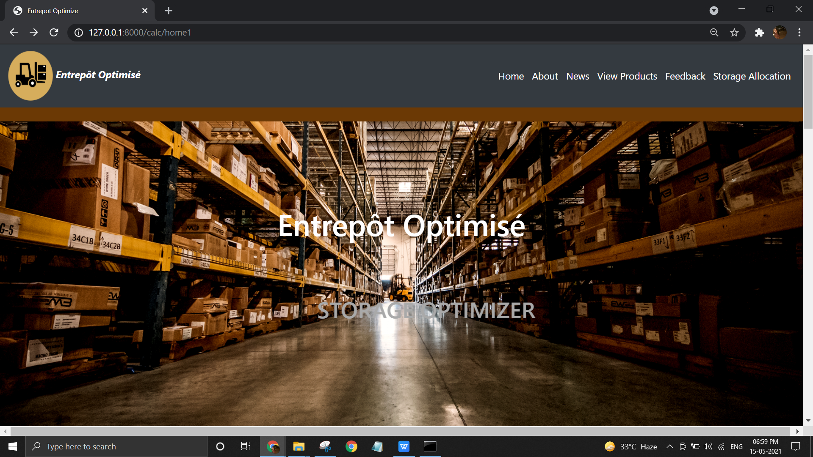

**About page:**

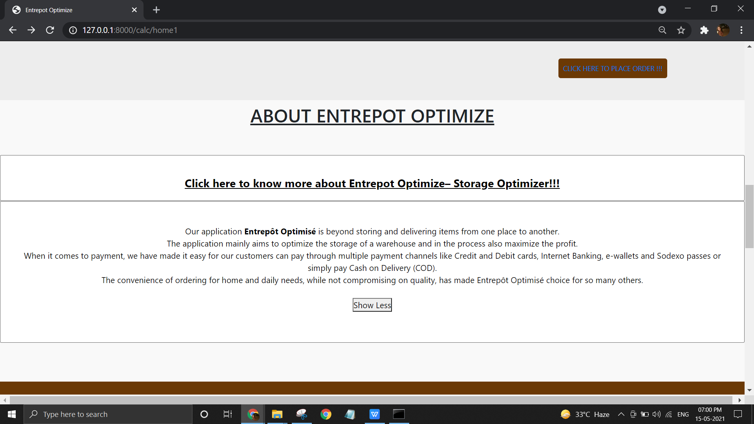

**Available Products Today:**

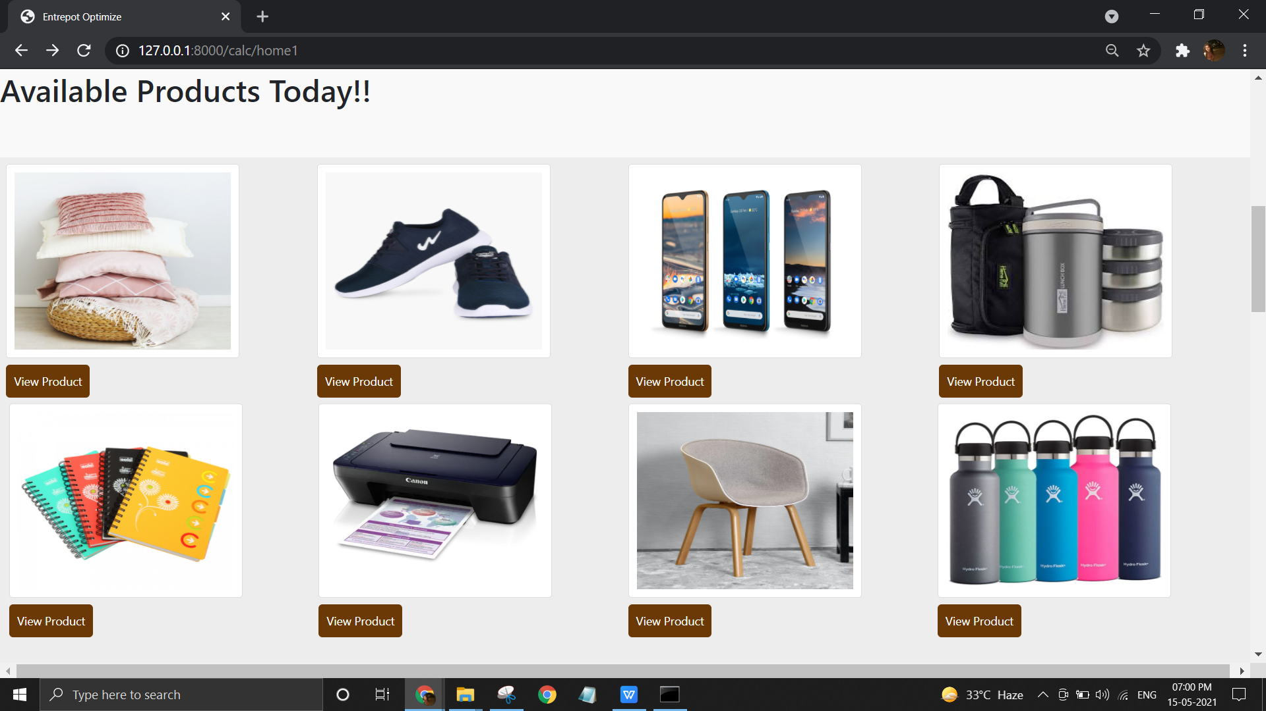

**News page:**

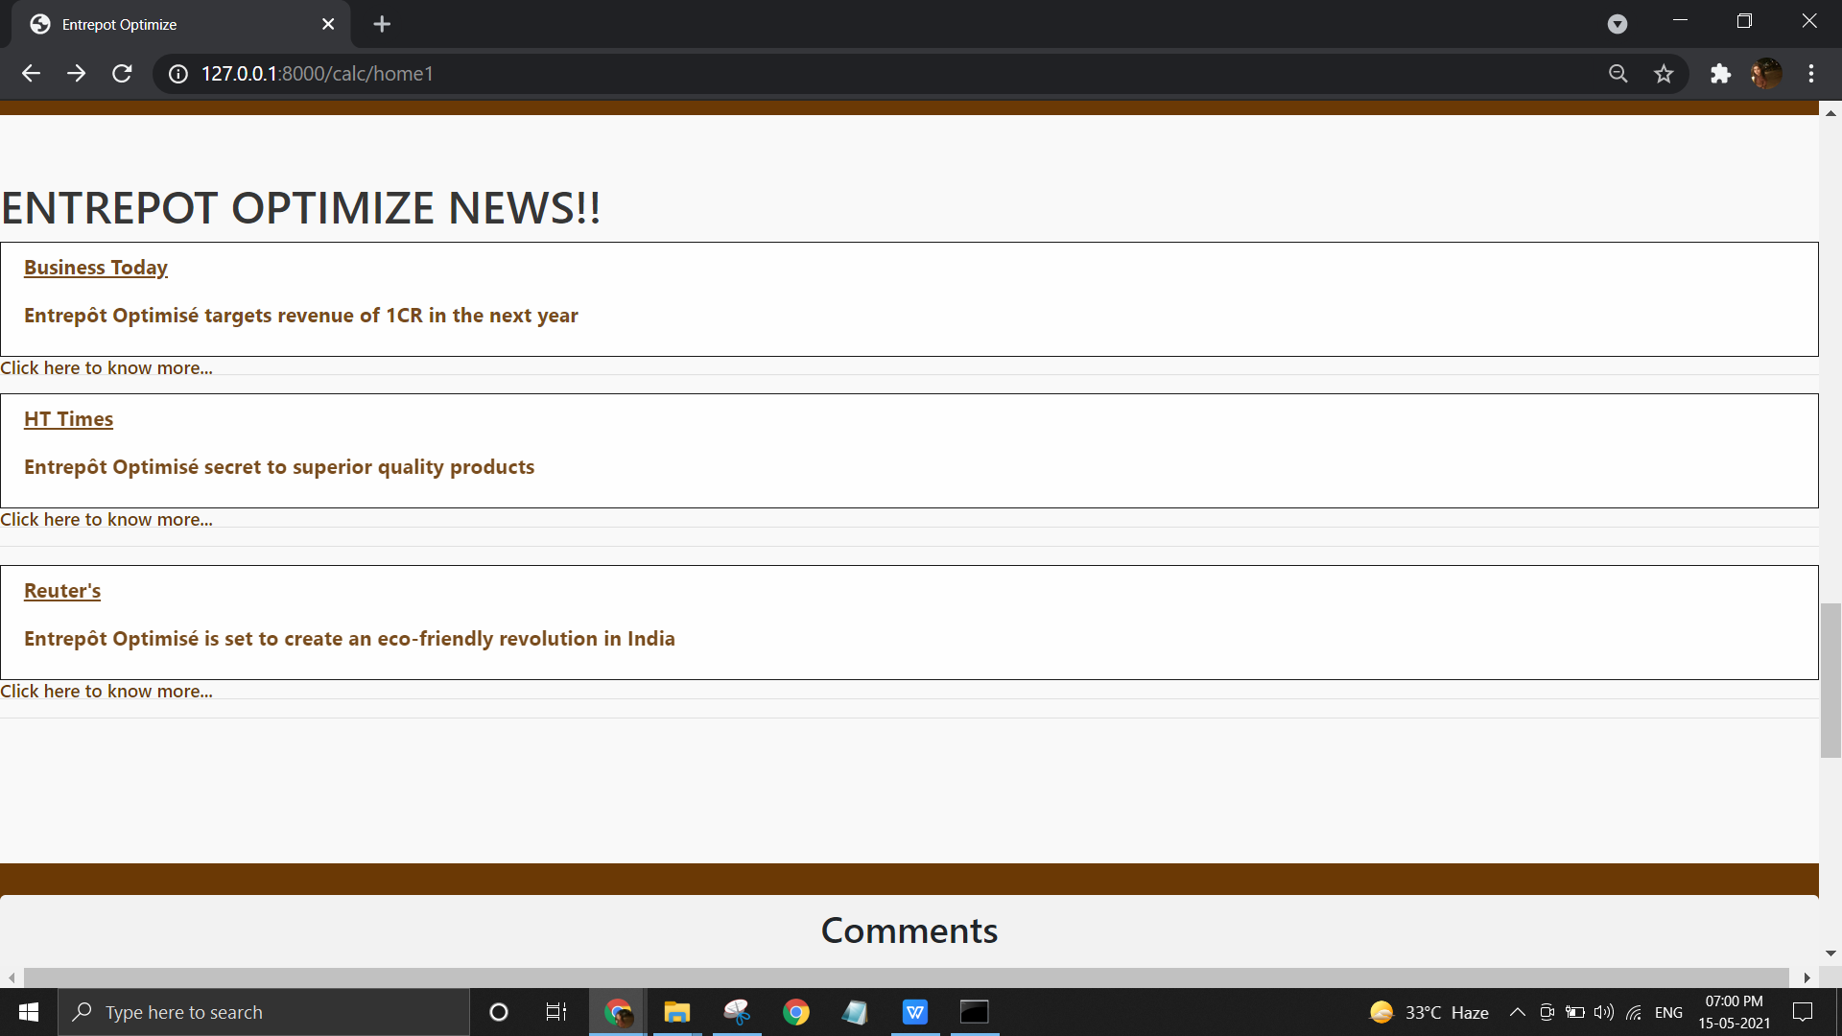

**Feedback page:**



**Storage Allocation page:**

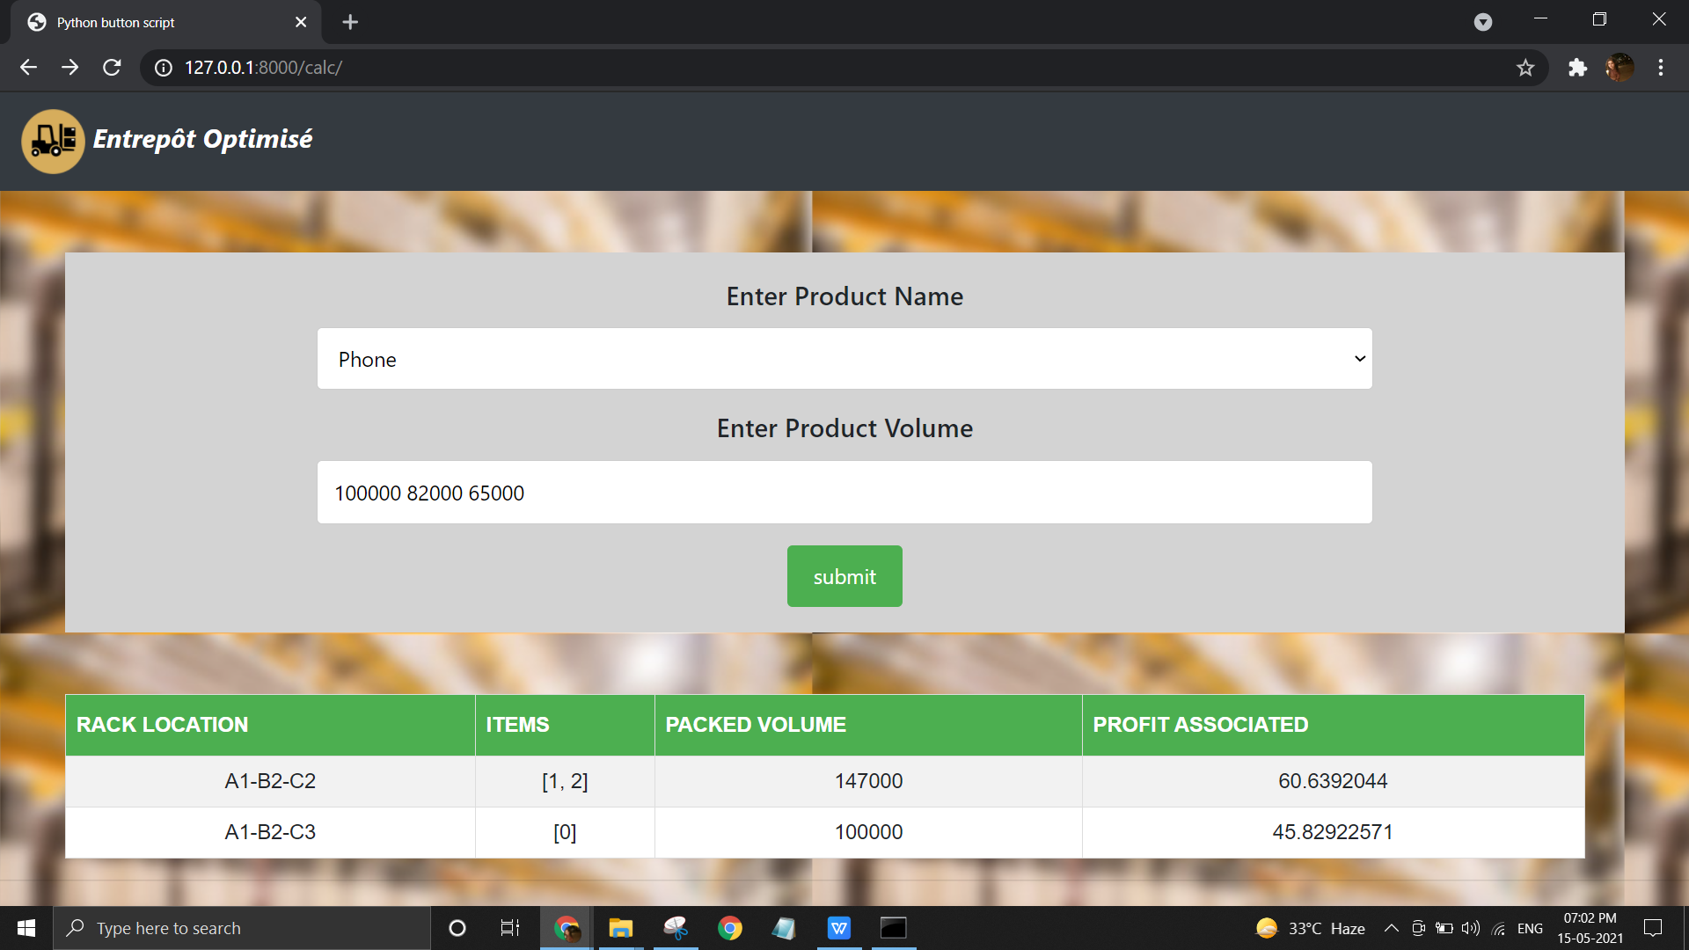

**Order Shipping and Receiving Forms :**

|  |  |
| --- | --- |
| **Data Record:** | **Data Record:** |

**Floor plan:-**

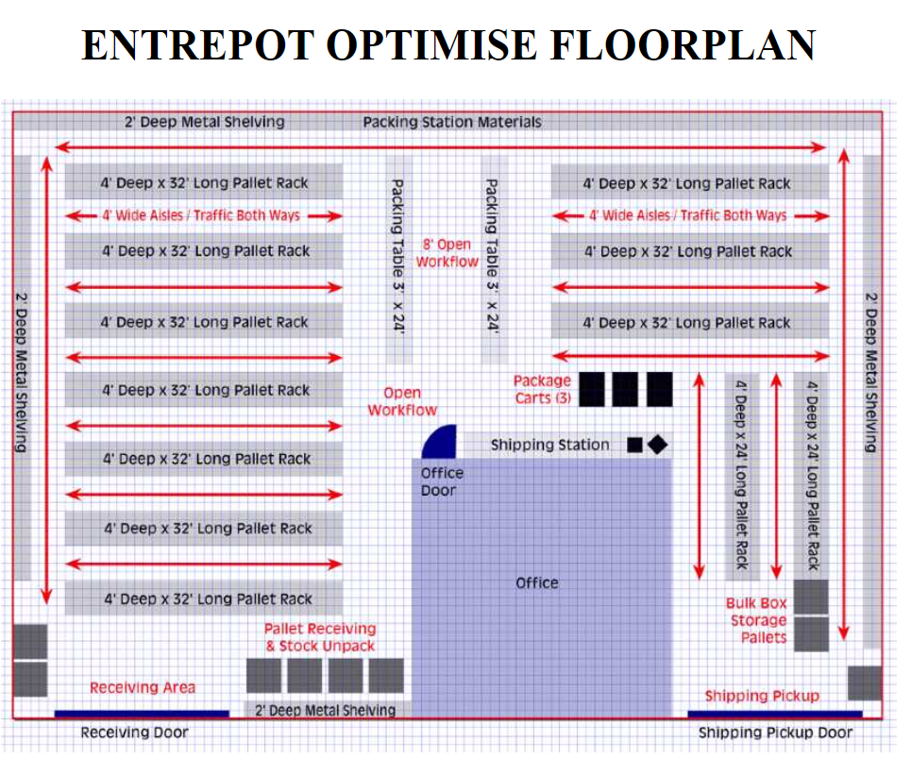

**CHAPTER 6: TESTING OF THE PROPOSED SYSTEM**

**6.1. TEST CASES AND RESULTS**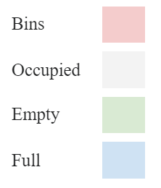

Consider 5 bins with 100% capacity available for storage. Now, the warehouse receives an order of *n* packages occupying some percent of volume $Vi$ associated with some profit $p_{i}$. Here, 4 orders are considered. The table below shows the received packages along with their volume occupied (in percent) and profit incurred as input. In the next two columns, a comparison between the allocation of these packages through traditional storage allocation method v/s the allocation through the Entrepôt Optimisé system has been shown. The last two columns display the total volume occupied and the profit gained during each input entry.

|  |  |  |  |  |  |  |  |  |  |  |  |  |
| --- | --- | --- | --- | --- | --- | --- | --- | --- | --- | --- | --- | --- |
| Input  Bin Numbers**→** | Traditional Allocation | | | | | Entrepôt Optimisé Allocation | | | | | Total  Volume | Total  Profit |
| 1 | 2 | 3 | 4 | 5 | 1 | 2 | 3 | 4 | 5 |
| 20 90 30 50  500 400 100 200 | 20 | 90 | 30  50 |  |  | 20  30  50 | 90 |  |  |  | 190 | 1200 |
| 30 10 50  200 300 200 | 20  30  10 | 90 | 30  50 | 50 |  | full | 90  10 | 30  50 |  |  | 280 | 1900 |
| 15 70 40 30  500 600 200 200 | 20  30  10  15 | 90 | 30  50 | 50  40 | 70  30 | full | full | 30  50  15 | 70  30 | 40 | 435 | 3400 |
| 50 20 30  600 100 100 | 20  30  10  15  20 | 90 | 30  50 | 50  40 | 70  30 | full | full | 30  50  15 | full | 40  50 | Traditional  455 3500  Entrepôt Optimisé  485 4000 | |

**Table 6.1 Traditional Vs. Entrepôt Optimisé System**

From the above sample’s analysis, it can be inferred that until there is enough empty space for storage, the total volume occupied by all packages and the profit incurred are the same. However, when the storage space is almost full before the fourth input the traditional method chooses packages based on a first come first serve basis without optimizing the space. For the same scenario, our system Entrepôt Optimisé picks the optimal packages, thus not only optimizing the storage space but also maximizing the profit of the warehouse. It is also observed that in the case of Entrepôt Optimisé after the first input, complete 3 bins are left empty for the next input and the storage is assigned to the first 2 bins whereas in the traditional method only 2 bins are completely empty for the next input. Similarly, after the second input 2 complete bins are empty whereas in the traditional system only one bin is left completely empty. Hence it is observed that Entrepôt Optimisé not only gives optimal solutions for storage allocation but also maximizes the overall profit associated with the products for the warehouse.

**CHAPTER 7: RESULT ANALYSIS**

**7.1.PERFORMANCE EVALUATION MEASURES**

* Planned

→ Admin, Client Login

→ Storage allocation using ML algorithms

→ Floor Plan layout planning

* Achieved

→ Storage allocation and optimization using Multiple Knapsack

→ Category based aisle allocation reducing picking distance

→ Using ML algorithm to identify product categories

* Extra features achieved

→ Profit optimization

**7.2 INPUT PARAMETERS/ FEATURES CONSIDERED**

* Name of the product
* Volume of the packages

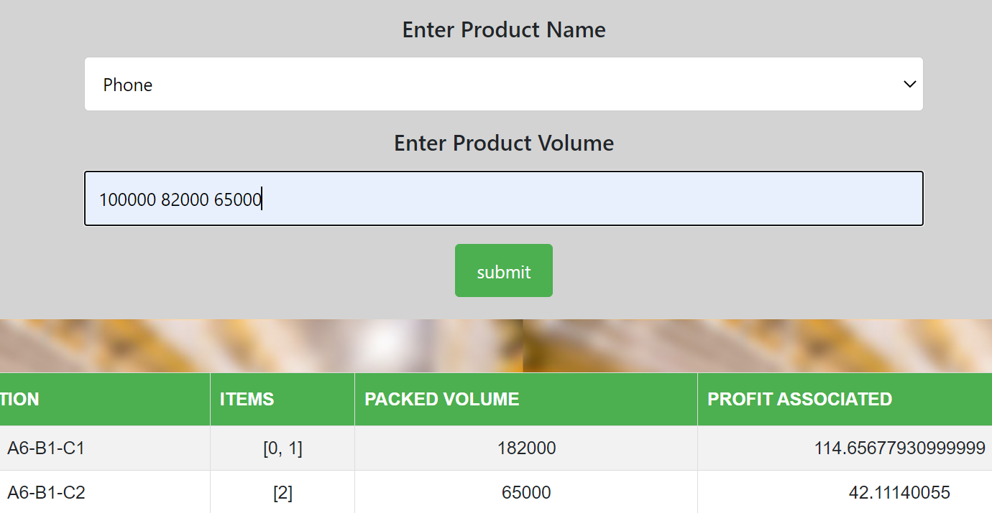

Fig 7.2.1 Input given through the web page

After entering the above two inputs, our system will identify the category and on the basis of this, it will allocate the best suitable storage for our received goods. The final output is shown below in Fig 7.2.2(a) and Fig 7.2.2(b).

**Fig7.2.2(a) Fig7.2.2**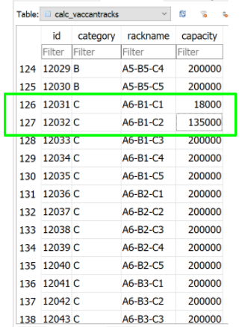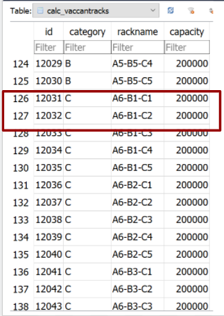

Fig 7.2.2(a) depicts the storage capacity in the initial state when no allocation is done. It can be seen that all the racks have been allocated to the same initial capacity ,but this algorithm works well even if the initial capacities of the racks are different. The result obtained by passing our input to the Storage Optimizing System is showcased in Fig 7.2.2(b).

**7.3 COMPARISON OF RESULTS WITH EXISTING SYSTEMS**

The comparison between traditional and our system based on input given in Table 6.1 is shown below in Table 7.3. It can be seen that the Entrepot Optimize system gives more profit and volume occupied is also greater as compared to traditional systems.

|  |  |  |  |
| --- | --- | --- | --- |
| TRADITIONAL | | ENTREPOT OPTIMIZE | |
| Total Profit % | Maximum Volume % | Total Profit % | Volume% |
| 83.33% | 85.04% | 95.24% | 90.65% |

Table 7.3

**7.4 INFERENCE DRAWN**

Using automation to improve warehouse operations brings a wide range of advantages, from running more efficiently to minimizing human error. Automation is a scalable, high-tech set up, which adapts to the operational systems and must-haves of each warehouse. Some benefits that we found were:

* Increased warehouse throughput
* Better resource utilization
* Reduced labor and operational costs
* Improved customer service
* Reduced handling and storage costs
* Reduced human error
* Minimized manual labor
* Increased productivity and efficiency
* Improved employee satisfaction
* Enhanced data accuracy and analysis
* Optimized warehouse space
* Greater inventory control
* Fewer shipping errors
* Reduced inventory loss
* Enhanced material handling coordination
* Improved order fulfillment accuracy

**CHAPTER 8: CONCLUSION**

**8.1 LIMITATIONS**

The shortcomings or limitations of our system will be not having

* A full fledged admin and client login.
* Our preferred floor layout planning
* Allocated storage for extra orders
* Automated updation of database on exit of goods

**8.2 CONCLUSION**

Warehouses are a predominant part of any supply chain industry. Considering the competition among e-commerce companies in today’s world, achieving storage efficiency is imperative. Our project Entrepôt Optimisé introduces an improved class-based storage strategy for small and large inventories. Optimized Storage Management is crucial in maximizing the sales profit margin of warehouses. A combination of Regression analysis, Classification model, and Multiple Knapsack algorithm has been used in our project for optimization of storage and maximization of profit. .Entrepôt Optimisé helps in allocating storage based on the demand and the profit associated and accommodates as many products in the warehouse depending on the availability of space. Careful application of Entrepôt Optimisé would result in a company-wide boost that brings cost-effectiveness and increased turnover.

**8.3 FUTURE SCOPE**

If we had more time to investigate, we would aim to improve and train our model to predict the demand along with possible shortage of products in the near future. Application of this in our model would help in allocating storage beforehand. For fast and efficient storage allocation, picking and receiving can be implemented using barcode generation and scanning. The data associated with the barcode can be accessed by the administrator to seek more information and take necessary measures. Implementation of barcodes can significantly reduce costs, manual work, errors, and speed up processes, hence improving the functioning of a warehouse.

**REFERENCES**

[[1]](https://searcherp.techtarget.com/definition/warehouse-management-system-WMS) Warehouse Management System

<https://searcherp.techtarget.com/definition/warehouse-management-system-WMS>

[[2]](https://www.supplychain247.com/article/the_problem_with_traditional_inventory_management) The Problem with Traditional Inventory Management

<https://www.supplychain247.com/article/the_problem_with_traditional_inventory_management>

[[3]](https://ieeexplore.ieee.org/document/7053577) Zizhuo Yang, Jun Wang, Qianmin Su and Bocheng Zhong, "The design of web-based warehouse management system," Proceeding of the 11th World Congress on Intelligent Control and Automation, 2014, pp. 5077-5081, doi: 10.1109/WCICA.2014.7053577.

[[4]](https://logisticslearningalliance.com/an-introduction-to-warehousing/) An introduction to Warehousing

<https://logisticslearningalliance.com/an-introduction-to-warehousing/>

[[5]](https://thereceptionist.com/blog/an-introduction-to-warehouse-management/) An Introduction to Warehouse Management

<https://thereceptionist.com/blog/an-introduction-to-warehouse-management/>

[[6]](https://www.researchgate.net/publication/260058173_Warehouse_Management_System_and_Business_Performance_Case_Study_of_a_Regional_Distribution_Centre#:~:text=Abstract,and%20their%20effects%20on%20operations.&text=WMS%20implementation%20is%20crucial%20in,company's%20competitiveness%20in%20strategic%20level.)Au Yong, Hui Nee. (2009). Warehouse Management System and Business Performance: Case Study of a Regional Distribution Centre.

[[7]](https://ieeexplore.ieee.org/abstract/document/7823494.) C. Zhou and Q. Fei, "Warehouse Management System Development Base on Open Source Web Framework," 2016 International Conference on Industrial Informatics - Computing Technology, Intelligent Technology, Industrial Information Integration (ICIICII), 2016, pp. 65-68, doi: 10.1109/ICIICII.2016.0027

[[8]](https://ieeexplore.ieee.org/document/5453745)S. Na, L. Xumin and G. Yong, "Research on k-means Clustering Algorithm: An Improved k-means Clustering Algorithm," 2010 Third International Symposium on Intelligent Information Technology and Security Informatics, 2010, pp. 63-67, doi: 10.1109/IITSI.2010.74.

[[9]](https://towardsdatascience.com/understanding-k-means-clustering-in-machine-learning-6a6e67336aa1) Understanding K-means Clustering in Machine Learning

<https://towardsdatascience.com/understanding-k-means-clustering-in-machine-learning-6a6e67336aa1>

[[10]](https://www.sciencedirect.com/science/article/abs/pii/S0377221798001209) David Pisinger, An exact algorithm for large multiple knapsack problems, European Journal of Operational Research, Volume 114, Issue 3, 1999, Pages 528-541, ISSN 0377-2217,

[[11]](https://link.springer.com/chapter/10.1007/978-3-540-24777-7_10) Kellerer H., Pferschy U., Pisinger D. (2004) Multiple Knapsack Problems. In: Knapsack Problems. Springer, Berlin, Heidelberg.

[[12]](https://www.researchgate.net/publication/260742754_An_Overview_of_Warehouse_Optimization) Karasek, Jan. (2013). An Overview of Warehouse Optimization. International Journal of Advances in Telecommunications, Electrotechnics, Signals and Systems. 2. 111-117. 10.11601/ijates.v2i3.61.

[[13]](https://analyticsindiamag.com/why-regression-analysis-is-the-backbone-for-enterprises/) Why Regression Analysis Is The Backbone For Enterprises

<https://analyticsindiamag.com/why-regression-analysis-is-the-backbone-for-enterprises/>

[[14]](https://www.veeqo.com/blog/warehouse-management) Warehouse Management: A Complete Guide for Retailers

<https://www.veeqo.com/blog/warehouse-management>

[[15]](https://www.myecole.it/biblio/wp-content/uploads/2020/11/10_SW_Smart_Warehouse_vs_Traditional_Warehouse.pdf) Smart Warehouse vs. Traditional Warehouse <https://www.myecole.it/biblio/wp-content/uploads/2020/11/10_SW_Smart_Warehouse_vs_Traditional_Warehouse.pdf>

**Appendix (Paper I & II Details)**

**1. Paper I & II Details**

1. **Plagiarism report**

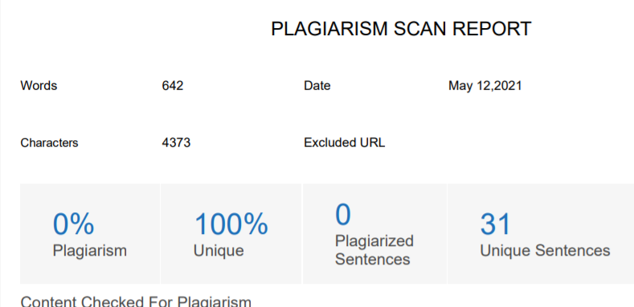

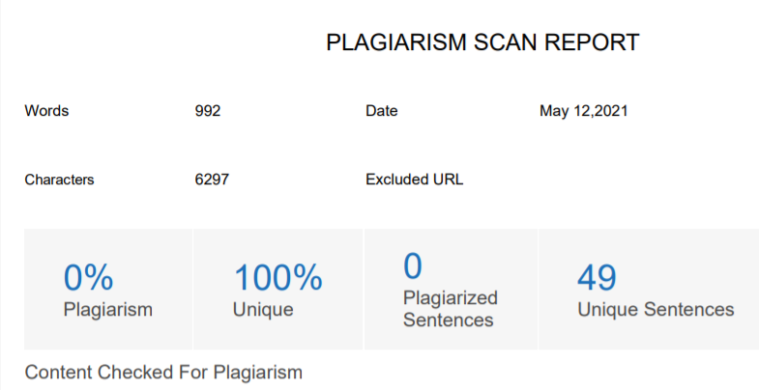

1. **Project review sheet**



**2. Video Presentation Link -** [**Upload here**](https://drive.google.com/drive/folders/1Mxg0bv_nC8vYf8pe71_bmBRuk7369iIn?usp=sharing)